**Daily Scrum or Standup Meeting**

Team name: ________Group 2_________________

Scrum Master: ______Emily_________________

Date:________10/24_______________________

| **Team Member** | **What did you do since the last scrum?** | **What do you plan to do before the next scrum?** | **What obstacles do you have?** |
| --- | --- | --- | --- |
| Emily Thomas | Finalized update markup percentage on menu editing page | Have Employees update hours worked | Waiting on updated user model |
| Karl Poulson | Fixed some styling issues | Finish order drink model | The complexities of css |
| Maris Hurst | Made html and logic for Manager creating a user account (and hooked up to managerView) | refactor user model finally | tiiiime |
| Andre Nguyen | Testing the Menu Model | Wrap up the Menu Model Item and connect it to the Drink Model | Class |
|  |  |  |  |

# Burndown

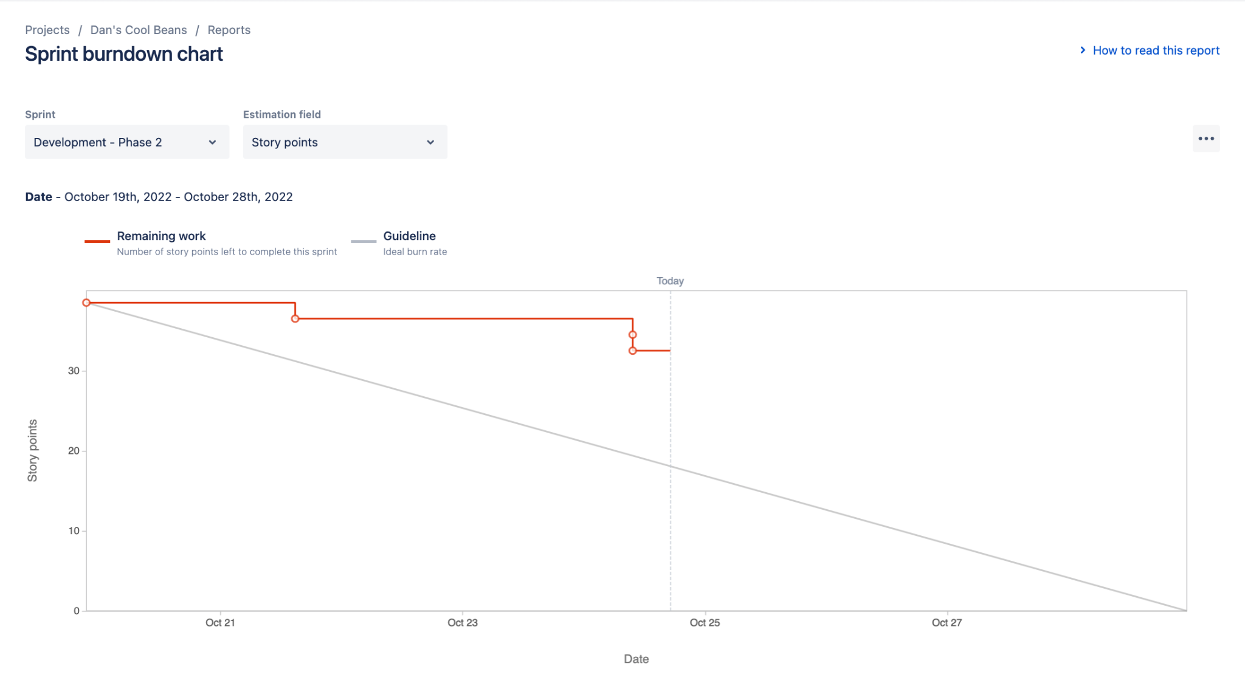

# Screenshot of you project board

